DIRECT DEPOSIT AUTHORIZATION

Please print and complete ALL the information below.

**Name**:

**Address**:

# City, State, Zip:

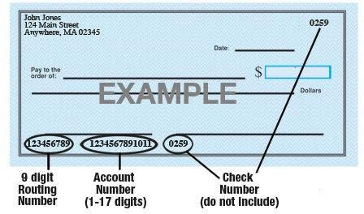

**Name of Bank**:

**Account #**:

# 9-Digit Routing #:

**Amount**: ◻ $ ◻ % or ◻ Entire Paycheck

**Type of Account**: ◻ Checking ◻ Savings (Check One)

*Attach a voided check for each bank account to which funds should be deposited (if necessary)*

[*Company Name*] is hereby authorized to directly deposit my pay to the account listed above. This authorization will remain in effect until I modify or cancel it in writing.

Employee’s Signature: [_](https://esign.com/)

Date: